Presentation to ACEC Ohio

(SPG - ODOT External Audits)

**I. BACKGROUND.**

* Federal Acquisition Regulation (FAR) 31.201-5 (codified at 48 CFR § 31.201-5)
* “[t]he applicable portion of any income, rebate, allowance, or other credit relating to any allowable cost and received by, or accruing to, the contractor shall be credited to the Government either as a cost reduction or by cash refund.”
* FHWA headquarters staff have communicated their views on the issues through presentations and discussions with various state DOT auditors
* FHWA issued ***Memorandum HCFB-30*** on March 24, 2021 to provide further guidance and clarification.

**II. USE OF INDIRECT COST RATES ON ODOT CONTRACTS.**

* FAR Part 31 indirect cost rates (ICR) for A/E firm’s most recently-completed fiscal year are used for billings and proposals within the ***effective period***.
* “Effective period” - date upon which ODOT approves an indirect cost rate through the date of approval in the subsequent year.

**Example**:

* ICR computed based on actual costs incurred from January 1 through December 31, 2020, and approved by ODOT on March 15, 2021 (the effective date).
* Applied to billings on actual-cost-plus-fixed-fee (actual cost) contracts and estimates on new contracts during the effective period.
* ODOT treats these rates as final contract rates.

**III. ADJUSTMENT REQUIRED FOR PPP LOANS FORGIVEN BY THE SMALL BUSINESS ADMINISTRATION.**

Recommendations for adjustments/credits required by FAR 31.201-5. (Only for forgiven PPP loan proceeds):

* Credited to the indirect cost rate to provide equitable allocation of the credit across different contracts and customer types. However, the credited rate only will affect FAR-based contracts.
* FAR-based contracts are contracts funded with State and/or Federal funds.
* **What is a FAR-based contract**? From ODOT Specifications Manual:

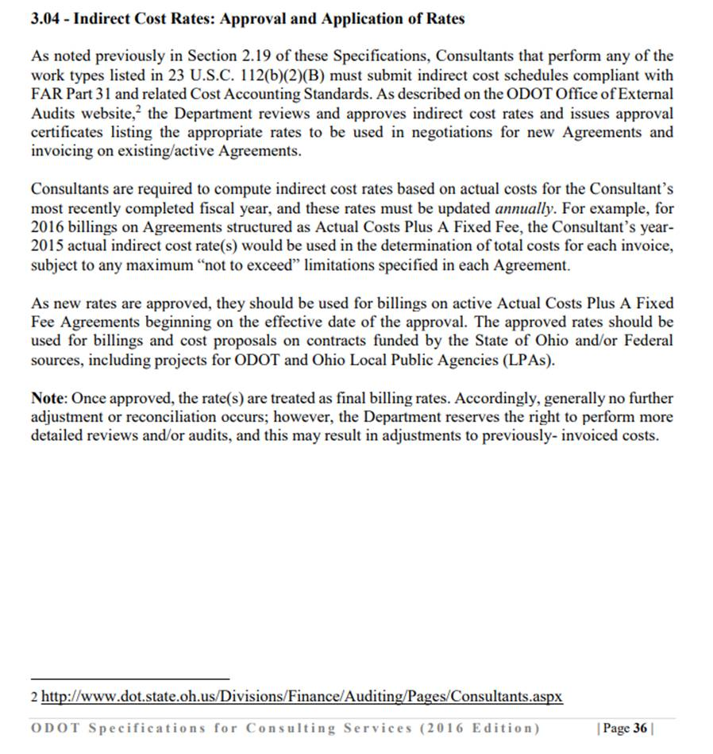

* Credit for PPP loan forgiveness will be made through a reduction to the A/E firm’s indirect cost rate for the year in which PPP funds were used/expended.
* Per FHWA guidance, ODOT will not accept direct credits to projects if PPP funds were initially expended for direct costs on ODOT contracts. PPP funds initially applied to ODOT contracts must be reallocated as indirect costs and credited to the indirect cost rate.
* Costs excluded from adjustment: direct costs on non-FAR based contracts, such as commercial contracts/projects.
* **Support for Exclusion**: Adequate documentation to identify the specific non-FAR based contract costs that were included on their PPP forgiveness application. (For example, direct costs excluded from the credit should be supported by job-cost and labor-distribution reports showing the direct costs that were excluded, including the project number, contract description, and the customer for each contract charged with such costs.)
* **Application of Post-PPP Rates**: Estimate costs and establish pricing and contract maximums on new contracts, but for multi-year contracts, the post-PPP rate (adjusted rate) will be used for the first year of the estimate only. For the portion of the estimate that extends beyond year 1, pre-PPP (unadjusted) indirect cost rates will be used.
* **Application: Contract Types**: The indirect cost rate credit for PPP loan forgiveness will be used for estimates on all contract types that use the indirect cost rate as a basis for determining total contract cost (total fee). Accordingly, this applies to estimates on lump-sum, rate-of-pay, and actual-cost-plus-fixed-fee contracts.

**IV. EXAMPLES.**

* **Example 1: Cost Estimates/Contract Maximums**. Firm A received PPP loan forgiveness in 2020. Firm A’s indirect cost rate is 175% before any adjustment for loan forgiveness. By contrast, its post-PPP adjusted indirect cost rate is 150%. Assuming that Firm A is negotiating a three-year contract with ODOT, the rates would be applied as follows, for purposes of determining the contract maximum:

|  |  |  |  |
| --- | --- | --- | --- |
|  | **Year 1** | **Year 2** | **Year 3** |
| Indirect cost rates used to determine maximum contract value (the not-to-exceed amount) | 150% | 175% | 175% |

* **Example 2: Billings on Actual-Cost Contracts**. In terms of billing on the three-year contract, the company would use 150% for year 1, then update its overhead rates in the subsequent years. Once ODOT approves the updated rates, Firm A would use those rates on billings in the subsequent years and potentially could bill amounts up to the contract maximum (not to exceed limit). E.g., If the Company’s approved rates for years 2 and 3 are 166% and 180%, respectively, then the billing rates, as applied to an actual-cost-plus-fixed-fee contract, are as follows:

|  |  |  |  |
| --- | --- | --- | --- |
|  | **Year 1** | **Year 2** | **Year 3** |
| Indirect cost rate billed | 150% | 166% | 180% |

Note: For the sake of brevity, the above examples depict an A/E firm with a unitary/corporate rate structure. For firms with separate indirect cost rates for Home Office and Field Offices, the same basic procedures regarding cost estimates and billings would apply; that is, the post-PPP rates would be used in year 1 for billings and cost estimations only.

**V. Paycheck Protection Program Certification Form.**

New disclosure requirement, Paycheck Protection Program Certification Form, as published on the ODOT External Audits webpage:

<https://www.dot.state.oh.us/Divisions/Finance/Auditing/Templates%20and%20Tools/Paycheck%20Protection%20Program%20(PPP)%20Certification.pdf>

**VI. ODOT EXTERAL AUDIT CONTACT.**

Direct questions regarding PPP loan forgiveness to:

Scot P. Gormley

Financial Program Manager

ODOT Office of External Audits

[Scot.Gormley@dot.ohio.gov](mailto:Scot.Gormley@dot.ohio.gov)